Tour New York
Take advantage of this incredible deals an see New york City this fall for only $1,250. the five-day vist include’s both airfar and lodgeing.
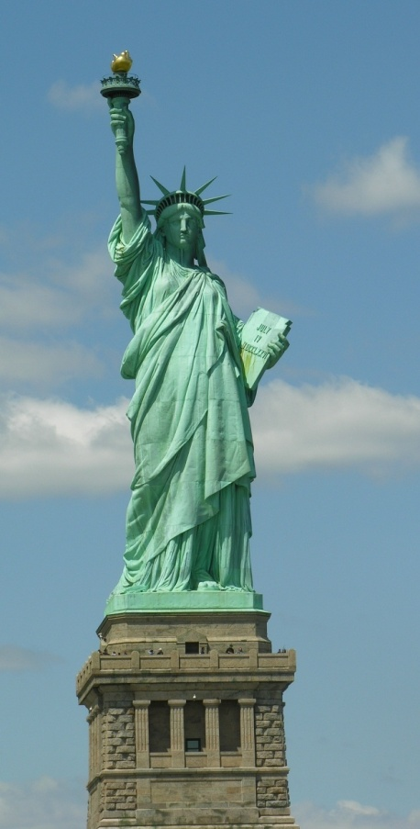
- Daily continentel breaksfast provided
- Discount event tickets and admision coupons fr area area attractions
- Limited group tours available

Call bay Travel reservations at 555-6788!

